Lab Load Interface (LLI) v0.4
Quick Start Guide
Oct 13, 2005

The following instructions help you get started quickly with the common tasks associated with using the Lab Loader Interface (LLI).

prerequisites
Before you can use the LLI utility, you must have a C3DS username and have been granted access to the Lab Load Interface utility. If you do not have a C3DS username or unsure of being granted access to LLI, you must contact NCICB Application Support, http://ncicbsupport.nci.nih.gov/sw/ , for assistance.

Login to Lab Load Interface
Accessing LLI is as simple as entering the following URL:
http://octrials-train.nci.nih.gov/opa45/labloadinter.htm
Note: This particular URL is associated with the TRAINING database version of LLI.

Once this page is activated, press the Login button.

When prompted, enter your C3DS username and password, as well as the database “OCTRN”, then press “Enter” or select the “Connect” button.

THe Lab Load Interface
The Lab Load Interface Lab Panel Search Screen consists of 3 main areas. The Search area “A” is for entering search criteria and performing searches; the Results section “B” will display those lab panels that match the entered search criteria; the Action section “C” contains buttons that perform actions on records selected in the results section. 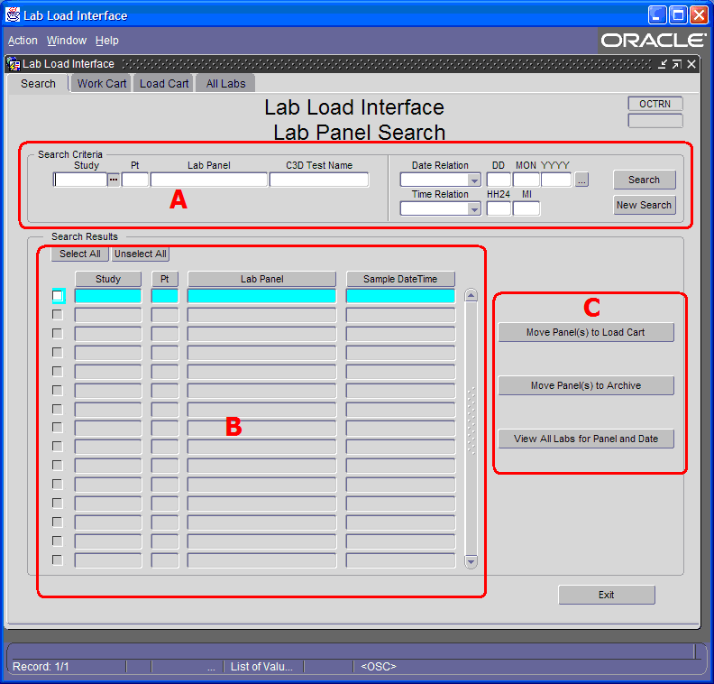

Primary objective
The primary objective of the Lab Loader Interface is to find the Panel of Lab Test Results needing loaded, and marking them so they will load into C3DS. This process consists of searching and marking.

Searching
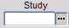
To search for Lab Tests Results that need reviewed, simply enter your study id into the “Study” field and select the “Search” button. You can also use the “List of Values” button next to the “Study” field to provide a list of Studies needing reviewed.

MARK FOR LOADING
To mark an entire Panel of Lab Test Results for Loading, simply select the panel from the list of search results, and press the “Move Panel(s) to Load Cart” button.
Once marked, the Panel will no longer appear in the Search Results section of the Search Tab. The Lab Test Results associated with the Lab Panel you selected will be processed and loaded during the next scheduled execution of the Lab Loader. The Lab Test Results will then appear in C3DS.

Exiting LLI
Once you have completed marking Lab Panels for loading, press the “Exit” button to leave the LLI Utility.

LLI Support
If you have question regarding the use of the Lab Load Interface, or encounter problems, contact NCICB Application support. For convenience, two links are provided within LLI under the “Help” menu item. The “NCICB App Support” item will open a browser window to the NCICB Application Support Home Page, while the “Mail To: NCICB App Support” item will initiate an e-mail message to NCICB Application Support.
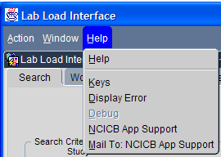

For more information on using the Lab Load Interface, please consult the “Lab Load Interface User Guide”.

